THE SUE KANTOR CLINICAL BONE DENSITOMETRY SCHOLARSHIP

The Australian and New Zealand Bone & Mineral Society (ANZBMS) invites applications for the Sue Kantor Clinical Bone Densitometry Scholarship, which will be awarded to a registrant at the ANZBMS Clinical Bone Densitometry Courses. An award will be made at the Course being held at Australian Catholic University (ACU) Melbourne 4-5 March 2017. One scholarship will be awarded. The successful applicant must agree to having their name placed on the ANZBMS website. The Scholarship provides the full registration fee for attendance at the Course. The decision of the ANZBMS in selecting a successful applicant is final.

BACKGROUND  Sue Kantor was born in 1958 and passed away after a short illness in December 2012. She was a foundation member of the ANZBMS Clinical BMD Faculty and a consummate contributor at all levels to the Clinical BMD courses since their inception in 2005. She had prepared herself well for this task, having worked in osteoporosis and bone densitometry for over 10 years, at both the Royal Melbourne and Children’s Hospitals. Sue was an integral member of both clinical teams and contributed to a large number of research papers, as well as running outstanding routine services. She was sent overseas to run training sessions and has had a significant impact in areas of bone densitometry software development. One of her contributions, a risk calculator was the subject of her doctoral studies, interrupted sadly by her death. | 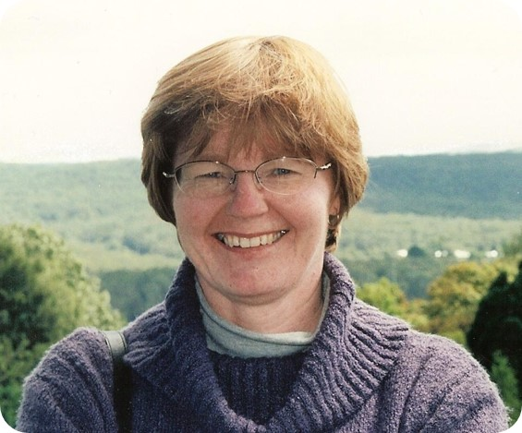

Before entering the bone densitometry field, Sue had established her expertise in the clinical and imaging sciences – she had completed her Masters in Educational Psychology, along with a Postgraduate Diploma of Adolescent and Child Psychology, a Graduate Diploma of Secondary Education, a Diploma of Therapeutic Radiography, and a Diploma of Applied Science in Medical Radiotherapy. Sue was a passionate educator and mentor. The ANZBMS believes that she would have thoroughly approved of the creation of a scholarship in her name, to assist in improving the quality of clinical practice in Australia.

ELIGIBILITY
An applicant should have imaging or therapy technologist, science or nursing qualifications. They would have already been accepted into a future ANZBMS Clinical Bone Densitometry Course. They must have worked in the bone densitometry field for at least 50% in the last full year, and must be currently employed in that field, working with patients. Preferably, they would be working in a combined research and clinical environment, though this is not a prerequisite. Experience in clinical and preclinical BMD studies, if relevant, should be stated. However, no special emphasis is placed on academic qualifications or achievements. The main emphasis is on a demonstrated personal commitment to patient care, based on a general understanding of the role of bone densitometry in relevant clinical practice.

HOW TO APPLY
There is no prescribed application form. An applicant should address all the eligibility criteria above, in no more than 300 words. They should indicate their past and expected future role in clinical bone densitometry. Please preferably pdf your application and email it to: dxa-course@anzbms.org.au. Please make the email heading ‘Sue Kantor Scholarship’. The deadline for applications is midnight Friday 24th February 2017.

ANNOUNCEMENT
The successful applicant will be announced at the wrap-up of the Course at Australian Catholic University on Sunday afternoon, March 5th.

ENQUIRIES
Please phone Roger Price on 0437 707 792 at any time, or email roger.price@health.wa.gov.au.

