2 March 2014
Re: Christina Vrahnas’ ANZBMS International Travel Award Report for Herbert Fleisch workshop 2014
To whom it may concern,
The ANZBMS travel grant awarded to me has allowed me to attend the first Herbert Fleisch workshop held in Brugge, Belgium. I was given the opportunity to present my work through an 8 minute oral as well as a poster highlighting the work from the first year of my PhD. The main reasons for attending this workshop were for me to make new connections and collaborations with other junior scientists, learn new ideas and methods and also meet and learn from the leaders in the bone field. I believe all of the above was achieved to help me further my career in research.
The workshop included state of the art lectures by Clifford Rosen, Michaela Kneissel, Jo Price, Brendan Lee and Roland Baron which highlighted the current main focuses in bone research today. It was amazing to hear and learn from people who have been in this field for over 10-20 years and really made me inspired to work towards being like them in the future, full of knowledge and new creative ideas.
Certain young investigators, including myself were given an opportunity to present their work through orals followed by an in depth discussion about what their work meant and how they can improve their findings. Presenting was not only a good learning experience but the discussion also gave me a lot to think about for my PhD thesis and future papers. I was approached by people raising good points about how I can explain my results as well as how to tackle some issues within my project. Discussions about my project is going to help me think more clearly as to what I should be doing next to further support my findings. Additionally, the poster viewing session not only allowed me to get even more ideas about my project, but it also gave me the courage to interact with other peers and ask about their projects. This was the first time I was able to really go in depth about other people’s work without feeling stupid for asking a simple question. The highlights for me were the social events such as the dinner and the reception where the real networking could take place. I was able to meet students and post docs from different countries and research backgrounds, which will be useful for me in the future when I may need to find a post doc position or for help with certain areas of work. I was also able to discuss my work with a postdoc whose work relates closely to mine and this gave me ideas on certain areas of my project which I should explore. A potential collaboration may come from this, therefore making this small and intimate conference a very successful one for me.

This travel grant also allowed me to visit Christa Maes lab in Leuven, Belgium. This was my first lab visit experience and gave me the opportunity to learn about the different work being done in an overseas lab. I also got the opportunity to present my work to her group and get feedback or advice on the next steps for my project. I learned the differences between how students work in Belgium compared to Australia as well as had in depth conversations with her PhD students’ work in progress and their plans after doing a PhD. This experience also helped me to give back to her lab by offering to teach them how to use a measuring technique which I learned off my supervisor and providing helpful tips for them around the lab. I plan to stay in contact with Christa and her students, and this will be another contact I have as a potential collaboration or place to do my post doc in the future.
Overall, I believe my four main goals were achieved. I was able to discuss my work with peers and senior scientists, learn about other students’ work which could in turn help my project, network with young investigators from all over the world which involved creating new connections for the opportunity of potential collaborations as well as future post-doc opportunities.
I’d like to thank the ANZBMS team for giving me the opportunity to use the travel grant in order to attend the Herbert Fleisch workshop and to further my career and achieve my goal in becoming a leading researcher in Australia.

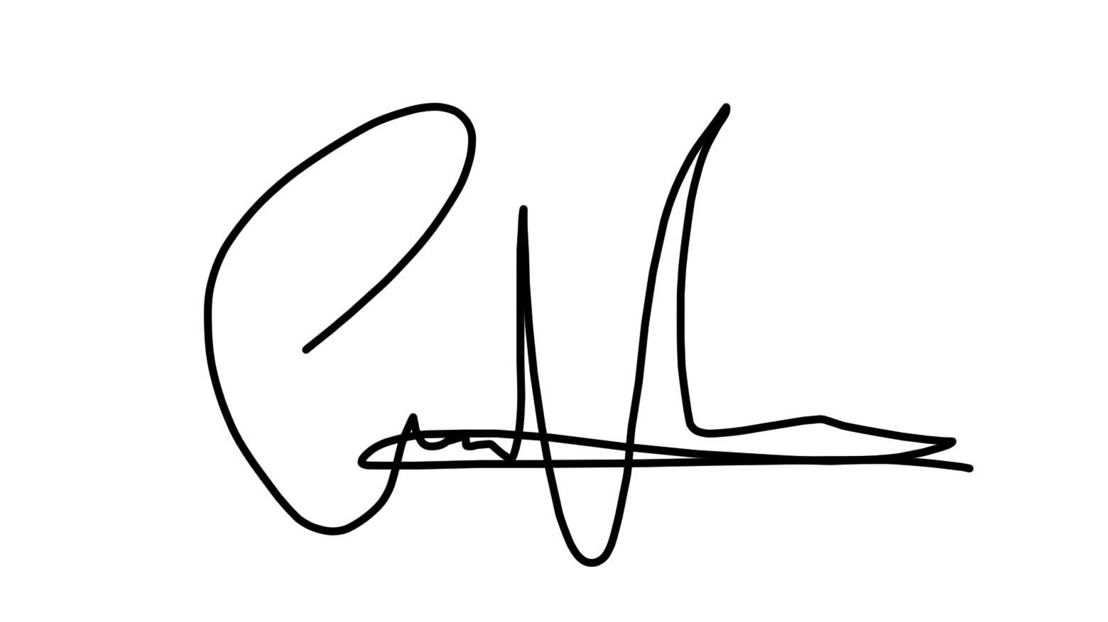
Christina Vrahnas
PhD Student
Bone Cell Biology and Disease Unit,
St Vincent’s Institute of Medical Research

