Recipient of the 2015 Award: Dr Sharon Brennan-Olsen
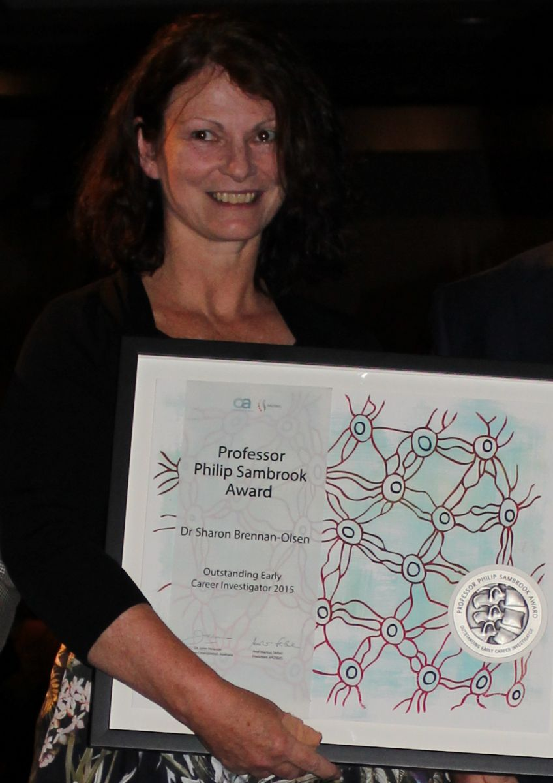

‘Does DNA Methylation Underpin the Social Gradient of Osteoporotic Fracture? A Conceptual Model.’
Dr Brennan-Olsen currently leads the Social Epidemiology Research Unit at Deakin University, conducting cross-disciplinary research in public health, epidemiology and health education. The cornerstone of Dr Brennan-Olsen’s recent work is the biology that underpins the social gradient of osteoporosis, hypothesising that socially disadvantaged individuals are at greater risk of osteoporotic fracture due to biological changes induced by chronic stress. Dr Brennan–Olsen and her colleague Dr Kara Holloway have presented this work at the 2015 American Society for Bone and Mineral Research annual meeting in Seattle, and the 2015 Australian and New Zealand Bone and Mineral Society Annual scientific meeting in Hobart.

