Phillip Sambrook Award 2014 – Kirtan Ganda
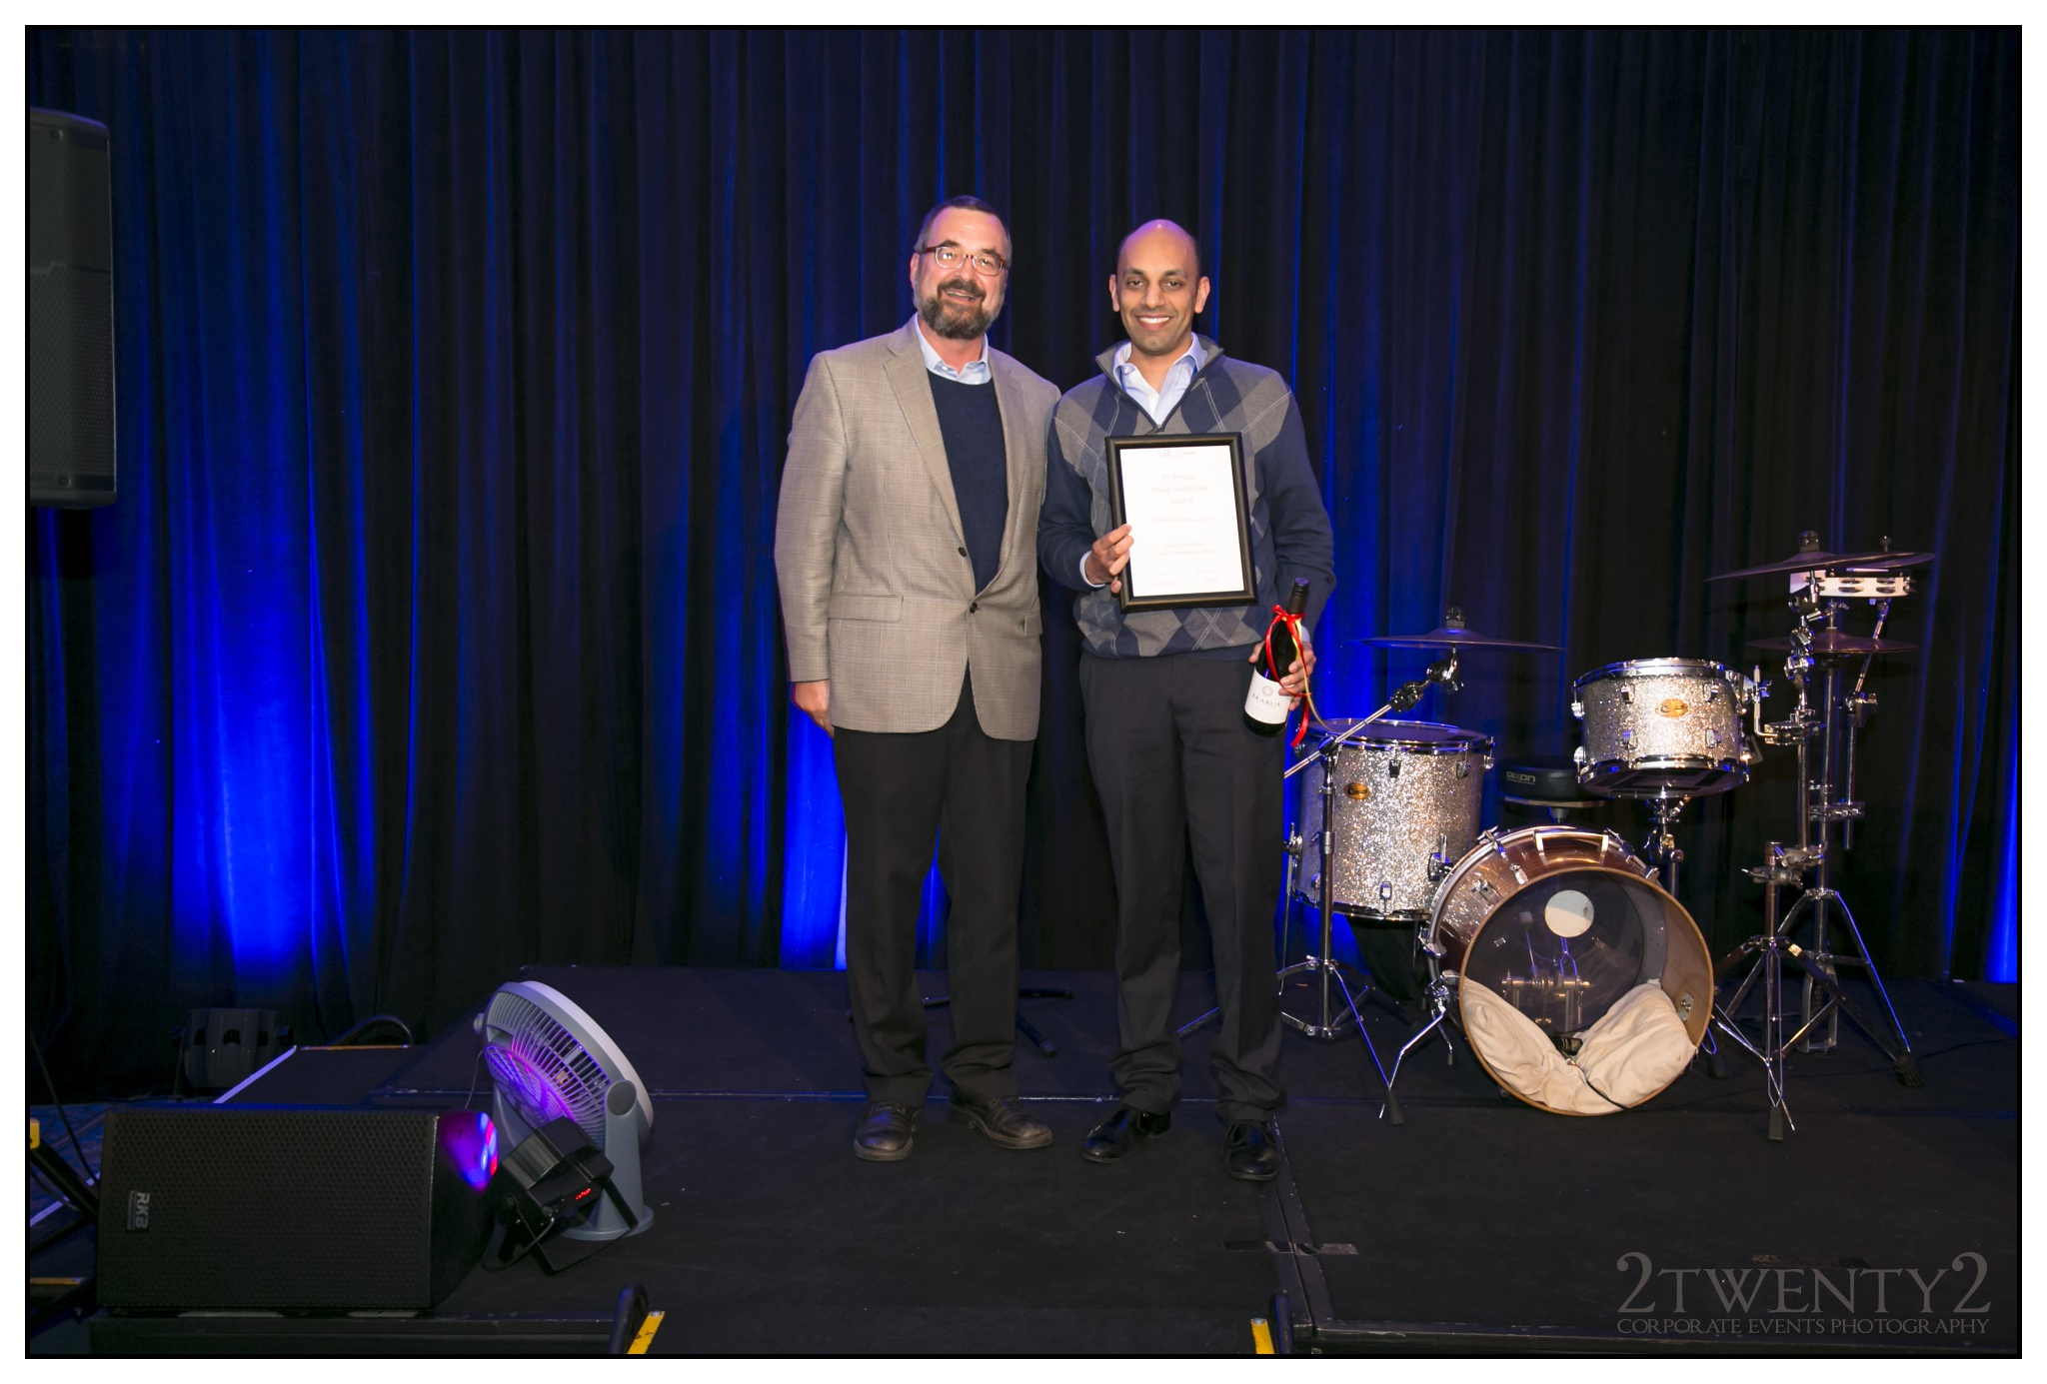

Dr Ganda is an endocrinologist at Sydney’s Concord General Repatriation Hospital. He has a strong commitment to improving bone health in the community through a combination of patient care, teaching and research. Dr Ganda’s research focusses on how best to prevent more fractures occurring in people who have already suffered a minimal trauma fracture due to osteoporosis, and an in-depth analysis of the effectiveness of the Minimal Trauma Fracture Service at Concord Hospital is the focus of his recently completed PhD. This research has been extended to include an analysis of secondary fracture prevention programs throughout Australia and overseas. Dr Ganda will use his award to present his latest findings at the Australian and New Zealand Bone and Mineral Society Annual scientific meeting in Queenstown, New Zealand, and the American Society for Bone and Mineral Research annual meeting in Houston, both taking place in September 2014.

